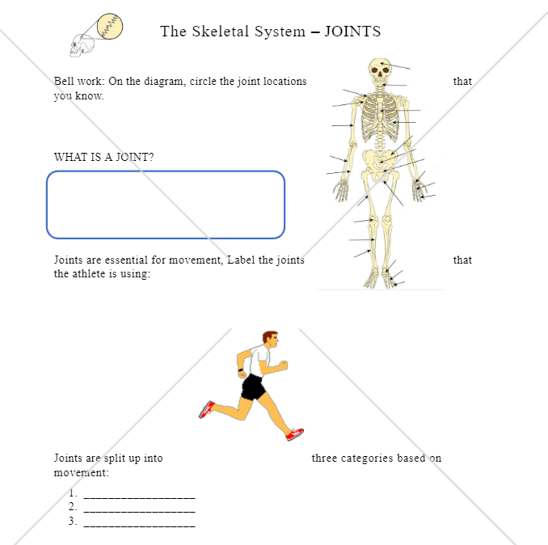

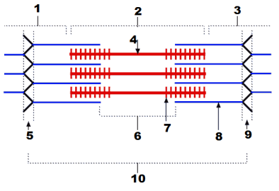
In the diagram on the left, what is
4_______________________________
7_______________________________
10______________________________

Explain how this works to cause movement in muscles (3 marks)
_______________________________________
_______________________________________
_______________________________________
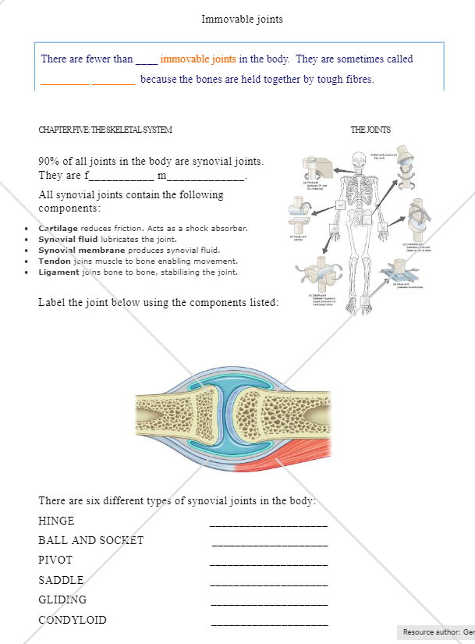

Draw a diagram below of adduction of the arm and abduction of the leg.

